System Requirements Statement (SRS) –

e-Worker Hiring

1. Introduction………………………………………………………………………3

2. Functional Requirements…………………………………………………...4

2.1 Worker Module…………………………………………………………………….5

2.2 Client Module……………………………………………………………………..11

2.3 admin Module……………………………………………………………………...18

2.4 message Acknowledgement Module……………………………………………21

2.5 USE CASE Diagrams………………………………………………………………22

THIS DOCUMENT CONTAINS 24 NUMBERED PAGES

# Introduction

This document explains the system requirements and scope for developing e-Worker Hiring System.

e-Worker Hiring System could divide the four main parts, Worker part, Client part, Admin part and the acknowledgement part.

This document describes the system requirement of the Account part.

# Functional Requirements

The Account part of e-Worker Hiring System has three modules which are divided into 25 processes described as below.

|  |  |  |
| --- | --- | --- |
| **No** | **BRS requirement ID** | **Description** |
| **2.1** | **Worker Module** | |
| **2.1.1** | **F1** | **Account Creation Process** |
| **2.1.2** | **F2** | **Login Process** |
| **2.1.3** | **F3** | **Forgot Password Process** |
| **2.1.4** | **F4** | **Change Password Process** |
| **2.1.5** | **F5** | **Update Account Process** |
| **2.1.6** | **F6** | **Delete Account Process** |
| **2.1.7** | **F7** | **View Requests** |
| **2.1.8** | **F8** | **Accept / Decline Request** |
| **2.2** | **Client Module** | |
| **2.2.1** | **F9** | **Account Creation Process** |
| **2.2.2** | **F10** | **Login Process** |
| **2.2.3** | **F11** | **Forgot Password Process** |
| **2.2.4** | **F12** | **Change Password Process** |
| **2.2.5** | **F13** | **Update Account Process** |
| **2.2.6** | **F14** | **Delete Account Process** |
| **2.2.7** | **F15** | **Place Requirement** |
| **2.2.8** | **F16** | **Update Requirement** |
| **2.2.9** | **F17** | **Remove Requirement** |
| **2.2.10** | **F18** | **Payment** |
| **2.3 Admin Module** | | |
| **2.3.1** | **F19** | **Login Process** |
| **2.3.2** | **F20** | **Forgot Password Process** |
| **2.3.3** | **F21** | **Change Password Process** |
| **2.3.4** | **F22** | **Update Account Process** |
| **2.3.5** | **F23** | **Report Generation** |
| **2.3.6** | **F24** | **Account Management** |
| **2.4 Message Acknowledgement Module** | | |
| **2.4.1** | **F25** | **Send Messages of Acknowledgement** |

## Worker Module

* Worker is the user of system who wants to get employed.

* He is able to view requests from clients.

### Account Creation Process

* e-Worker Hiring System compels to create the account before using it. So, e-Worker Hiring System should provide the function which makes Workers to create new account.
* When Worker creates new account, the function demands user information described as below.

1. Login information
2. Contact Details

* The Login information consists of some items described as below.

1. UserId
2. Password
3. First Name
4. Last Name
5. E-mail address
6. User Type
7. Worker Type
   * All items are compulsory demanded.
   * UserId

* The UserId should be unique. If the UserId correspond with not case-sensitive to other which is previously registered, the UserId should not be registered as an account.
  + Password
* The Password has constrains which makes the Password consists of more than or equal 8 and less than or equal 16 characteristics including characters described as below.

1. Numeric figure (at least one)
2. Capital alphabet (A-Z)(at least one)
3. Small alphabet (a-z)(at least one)
4. Special character (#, $, %, &, etc.) (at least one)

* The Password is masked by dummy characters. The re-entering Password is demanded.
* The Password must be encrypted in e-Worker Hiring System.
* User Types

The User Type falls into three categories described as below.

1. Worker
2. Client
3. Administrator

* The User Type defines also three types of user; "Worker user", "Client user", and "Administrator user”.
* In an Account Creation Process, the client can request for number of Workers.
* No one could select The Administrator, because Administrator is implemented to e-Worker System in advance.
* Worker Types

The Worker Type falls into two categories described as below.

1. Skilled Workers

2. Unskilled Workers

* The Worker Type defines two types of user; "Skilled Workers" and "Unskilled Workers".
* Skilled Workers contains Workers such as Electricians,Plumbers, Carpenters etc.
* Unskilled Workers are those who does not have any specific skill and can go for any work offered to him.
* Contact Details:
* The Contact Detail consists of some items described as below.

1. Permanent Address
2. Contact Phone No.

* All items are compulsory demanded.
* Permanent Address
* Permanent Address should be filled.
* But only the state should be selected from options.
* The Security Question information

The Security Question information is needed when Worker lost their password. This information consists of two items described as below.

1. Selected Question
2. Answer
   * All items are compulsory demanded.
   * Some questions which are difficult to answer for anyone else are prepared in advance.

E.g. which is your favorite sport?

* + A question should be selected from options by the Worker, and the Answer is registered by the Worker.
* Login information should be entered on one screen, and then Worker information and Security Question information should be entered on another screen.

### Login Process

* e-Worker System always compels user authentication before using itself except when a new account is successfully created.
* The user authentication demands UserId and Password. The UserId and the Password should be checked in three ways.
  + First, The UserId and the Password should be existed and correct.
* If the UserId and the Password are not equal to what the user has registered, the user authentication cannot be provided.
  + Second, the User Type linked to the UserId should be "Worker".
* When the User Type is "Worker", then user can be placed on “Worker Home”.
  + Finally, UserId should be available.
* The Administrator can decide whether the UserId is available or suspended – Refer to the SRS of the Admin part.
* If Worker is rejected, user authentication is not provided for system user.
* The Worker account should alive for so long as the duration decided by Admin.
* Only when the three checks are successfully completed, Worker can be placed on respected page.
* The “Worker Home” provides some items described as below.

1. A trigger to logout
2. A trigger to update Account
3. A trigger to Change Password
4. A trigger to Delete Account
5. A trigger to View Service Request
6. A trigger to Accept the request
7. A trigger to Decline the request

### Forgot Password Process

* When system user lost their Password, the recovery method should be provided by.

e-Worker Hiring system

The recovery method is described as below.

* + First, system user enters their userId for e-Worker Hiring System.
  + Next, e-Worker Hiring system demands the Answer which has been registered since when the Account was created.
  + Only when the Answer is correct, Worker gets the new password by E-mail which also has been registered since when the Account was created.
  + The new password is automatically generated by e-Worker Hiring system.
* Of course, the new password should consist of more than or equal 8 and less than or equal 16 characteristics including at least a numeric figure, a capital alphabet, a small alphabet, and a special character.
* As a consequence, The Worker could get the Worker authentication using the new password.
  + Then, the Worker had better change the new password manually.
* If the Answer is not correct, otherwise, the correct Answer is demanded for user again.
  + In that case, Of course, Worker couldn’t get the new password.

### Change Password Process

* When Worker wants to change their Password, the measure should be provided by e-Worker Hiring system.
* Therefore, e-Worker Hiring system should provide the function which is available after getting the Worker authentication.
* The function demands the current password and the new password.
  + Of course, the new password should consist of more than or equal 8 and less than or equal 16 characteristics including at least a numeric figure, a capital alphabet, a small alphabet, and a special character.
  + The current password and the new password are masked by using dummy characters.
  + The new password is demanded to enter twice to avoid a typing error.
* Only when the current password is correct, Worker could change their Password.
* When the current password is changed into new password, e-Worker Hiring system compels user authentication again.

### Update Account Process

* e-Worker Hiring system should provide the function which makes the account updated for Worker.
* The information Worker could update is described below.

1. Login information
2. User information
3. Security Question Information

* The Login information

The updatable items as described below.

1. First Name
2. Last Name
3. E-mail address
   * All items are compulsory demanded, but updating is optional.

* The User information

The updatable items as described below.

1. User Name
2. User Phone No
3. E-mail address
4. Permanent address
   * All items are compulsory demanded, but updating is optional.

* The Security Question information

The updatable items as described below.

1. Selected Question
2. Answer
   * All items are compulsory demanded, but updating is optional.

### Delete Account Process

* If Worker does not want to stay with our portal then Worker can send request to delete his account to admin with the help of message acknowledgement by verifying with his current password.
  + 1. **View Service Requests**
* Service Requests are described as below.

1. Client’s Personal Details which include

* Name
* Contact Information

1. Work Details

* Job Description
* Address
* Number of days

### 2.1.8 Accept / Decline Request

* Worker can accept request or decline request as per his availability

#### 2.2 Client Module

### 2.2.1 Account Creation Process

* E-Worker System compels to create the account before using it. So, E-Worker System should provide the function which makes client creates new account.
* When client creates new account, the function demands four information described as below.

1. Login information

2. Contact Details

3. Security Question Information

4. Payment information.

* The Login information

The Login information consists of some items described as below.

1. UserID

2. Password

3. First Name

4. Last Name

5. E-mail address

6. User Type

7. Client Type

* + All items are compulsory demanded.
  + UserID
* The UserID should be unique. If the UserID correspond with not case-sensitive to other which is previously registered, the UserID should not be registered as an account.
  + Password
* The Password has constraints which makes the Password consists of more than or equal 8 and less than or equal 16 characteristics including characters described as below.

1. Numeric figure (at least one)

2. Capital alphabet (A-Z) (at least one)

3. Small alphabet (a-z) (at least one)

4. Special character (#, $, %, &, etc.) (at least one)

* The Password is masked by dummy characters. The re-entering Password is demanded.
* The Password must be encrypted in E-Worker System.
  + User Type

The User Type falls into three categories described as below.

1. Worker

2. Client

3. Administrator

* The User Type defines also three types of user; " Worker user", "Client user", and "Administrator user”.
* In an Account Creation Process, the user can select Client.
* No one could select The Administrator, because Administrator is implemented to E-Worker System in advance.
  + Client Type

The Client Type falls into two categories described as below.

1. Contractor

2. Other

* The User Type defines also two types of Client; "Contractor client" and "Others client".
* Contractor client place request same type of Workers frequently.
* Others client place request as per their requirement.
* Contact Details
* The Contact Detail consists of some items described as below.

1. Permanent Address

2. Contact Phone No

* + All items are compulsory demanded.
  + Permanent Address
* Permanent Address should be filled.
* But only the state should be selected from options.
* The Security Question information

The Security Question information is needed when Client lost their Password. This information consists of two items described as below.

1. Selected Question
2. Answer
   * All items are compulsory demanded.
   * Some questions which are difficult to answer for anyone else are prepared in advance.

E.g. which color do you like most?

* + A question should be selected from options by the Client, and the Answer is registered by the Client.
* Login information should be entered on one screen, and then Client information and Security Question information should be entered on another screen.

### 2.2.2 Login Process

* E-Worker System always compels Client authentication before using itself except when a new account is successfully created.
* The user authentication demands UserID and Password. The UserID and the Password should be checked in three ways.
  + First, The UserID and the Password should be existed and correct.
* If The UserID and the Password are not equal to what the user has registered, the user authentication cannot be provided.
  + Second, the User Type linked to the UserID should be "user".
* When the User Type is " Client ", user can be placed on “Client Home”.
  + Finally, UserID should be available.
* The Administrator can decide whether the UserID is available or suspended – Refer to the SRS of the Admin part.
* If user is rejected, user authentication is not provided for Client.
* The Client account should alive for so long as the duration decided by Admin.
* Only when the three checks are successfully completed, Client can be placed on respected page.
* The “Client Home” provides the some items described as below.

1. A trigger to logout
2. A trigger to update Account
3. A trigger to Change Password
4. A trigger to Place Request
5. A trigger to Payment Process
6. A trigger to Delete Account

### 2.2.3 Forgot Password Process

* When Client lost their Password, the recovery method should be provided by E-Worker system.

The recovery method is described as below.

* + First, Client enters their UserID for E-Worker System.
  + Next, E-Worker System demands the Answer which has been registered since when the Account was created.
  + Only when the Answer is correct, Client get the new password by E-mail which also has been registered since when the Account was created.
  + The new password is automatically generated by E-Worker System.
* Of course, the new password should consist of more than or equal 8 and less than or equal 16 characteristics including at least a numeric figure, a capital alphabet, a small alphabet, and a special character.
* As a consequence, The Client could get the user authentication using the new password.
  + Then, the Client had better change the new password manually.
* If the Answer is not correct, otherwise, the correct Answer is demanded for Client again.
  + In that case, Of course, Client couldn’t get the new password.

### 2.2.4 Change Password Process

* When Client wants to change their Password, the measure should be provided by E-Worker System.
* Therefore, E-Worker System should provide the function which is available after getting the Client authentication.
* The function demands the current password and the new password.
  + Of course, the new password should consist of more than or equal 8 and less than or equal 16 characteristics including at least a numeric figure, a capital alphabet, a small alphabet, and a special character.
  + The current password and the new password are masked by using dummy characters.
  + The new password is demanded to enter twice to avoid a typing error.
* Only when the current password is correct, Client could change their Password.
* When the current password is changed into new password, E-Worker System compels Client authentication again.

### 2.2.5 Update Account Process

* E-Worker System should provide the function which makes the account updated for Client.
* The information Client could update is described below.

1. Login information

2. User information

3. Security Question Information

* The Login information

The updatable items as described below.

1. First Name
2. Last Name
3. E-mail address
   * All items are compulsory demanded, but updating is optional.

* The User information

The updatable items as described below.

1. User Name
2. User Phone No
3. E-mail address
4. Permanent address
   * All items are compulsory demanded, but updating is optional.

* The Security Question information

The updatable items as described below.

1. Selected Question
2. Answer
   * All items are compulsory demanded, but updating is optional.

**2.2.6 Delete Account**

* If Client does not want to stay with our portal then Client can send request to delete his account to admin with the help of message acknowledgement by verifying with his current password.

#### 2.2.7 Place Requirements

* Placing requirements include information such as

1. Worker Type

2. Worker Count

3. Number of days

4. Employment Address

5. Work Details

6. Contact details

#### 2.2.8 Update Requirements

* After placing request if Client want to make changes in the current request then he can update it. Updating requirements includes updation of :
* Worker Type
* Worker Count
* Number of days
* Employment Address
* Work Details
* Contact details

**2.2.9 Remove Requirement**

* Client can remove requirement, if he want to complete the work by other means.

**2.2.10 Payment**

* In payment process system, Client pays amount at the time of placing request.

1. To whom client has to make payment (name and Account Details)
2. Payment amount
3. Payment Date and time
4. Payment status
5. Mode of payment
6. Transaction Id

#### 2.3 Admin Module

* Administratorshould be responsible for following activities

### 2.3.1 Login Process

* E-Worker System always compels user authentication before using itself except when a new account is successfully created.
* The user authentication demands UserID and Password. The UserID and the Password should be checked in three ways.
  + First, The UserID and the Password should be existed and correct.
* If The UserID and the Password are not equal to what the admin has registered, the Admin authentication cannot be provided.
  + Second, the User Type linked to the UserID should be "Admin".
* When the User Type is "Admin", user can be placed on “Admin Home”.
  + Finally, UserID should be available.
* The Administrator can decide whether the UserID is available or suspended – Refer to the SRS of the Admin part.
* If user is rejected, user authentication is not provided for system user.
* The Admin account should alive for so long as the duration decided by Admin.
* Only when the three checks are successfully completed, Admin can be placed on respected page.
* The “Admin Home” provides the some items described as below.

1. A trigger to logout
2. A trigger to update Account
3. A trigger to Change Password
4. A trigger to Search Workers
5. A trigger to Publish Wages for Workers
6. A trigger to Update employment Information
7. A trigger to Delete employment
8. A trigger to Change existing Worker wages

### 2.3.2 Forgot Password Process

* When Admin lost their Password, the recovery method should be provided by E-Worker system.

The recovery method is described as below.

* + First, Admin enters their UserID for E-Worker System.
  + He will enter the E-mail id since when the Account was created.
  + Only when the E-mail Id is correct, Admin get the new password by E-mail which also has been registered since when the Account was created.
  + The new password is automatically generated by E-Worker System.
* Of course, the new password should consist of more than or equal 8 and less than or equal 16 characteristics including at least a numeric figure, a capital alphabet, a small alphabet, and a special character.
* As a consequence, The Admin could get the Admin authentication using the new password.
  + Then, the Admin had better change the new password manually.

### 2.3.4 Change Password Process

* When Admin wants to change his Password, the measure should be provided by E-Worker System.
* Therefore, E-Worker System should provide the function which is available after getting the Admin authentication.
* The function demands the current password and the new password.
  + Of course, the new password should consist of more than or equal 8 and less than or equal 16 characteristics including at least a numeric figure, a capital alphabet, a small alphabet, and a special character.
  + The current password and the new password are masked by using dummy characters.
  + The new password is demanded to enter twice to avoid a typing error.
* Only when the current password is correct, Admin could change his Password.
* When the current password is changed into new password, E-Worker System compels user authentication again.

### 2.3.4 Update Account Process

* E-Worker System should provide the function which makes the account updated for Admin.
* The information Admin could update is described below.

1. Login information
2. User information
3. Security Question Information

* The Login information

The updatable items as described below.

1. First Name
2. Last Name
3. E-mail address
   * All items are compulsory demanded, but updating is optional.

* The User information

The updatable items as described below.

1. User Name
2. User Phone No
3. E-mail address
4. Permanent address
   * All items are compulsory demanded, but updating is optional.

* The Security Question information

The updatable items as described below.

1. Selected Question
2. Answer
   * All items are compulsory demanded, but updating is optional.

#### 2.3.5 Record Generation

• Admin should able to see all the records from any users.

• Daily report of enrolment to admin.

• Monthly report of enrolment as per the states to admin.

#### Accounts Management

• Admin should able to manage all the accounts with following activities,

1. Enable accounts

2. Disable accounts

#### 2.4 Message Acknowledgement Module

* In following conditions acknowledgement to be send

1. After completion of successful registration.
2. After every successful transaction the acknowledgement is sent to Worker and client by using email and notifications.

#### 2.5 Use Case Diagrams

* **Admin:**

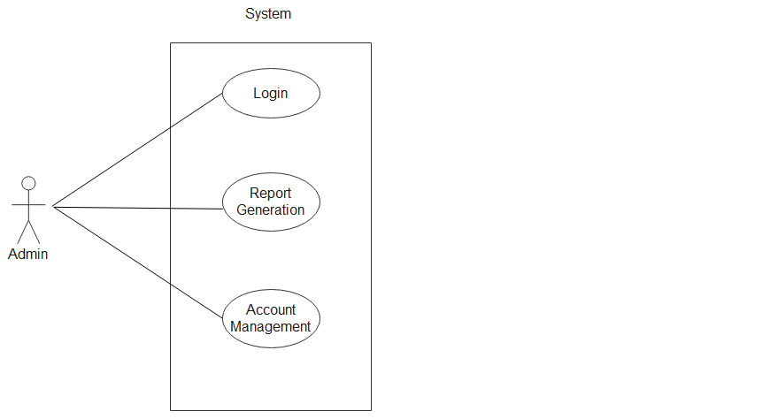

*Fig. Use case diagram for admin*

1. In Admin use case diagram Admin is the Actor.
2. Admin can handle following use cases:
3. Login
4. Report Generation
5. Controls account

* **Worker:** 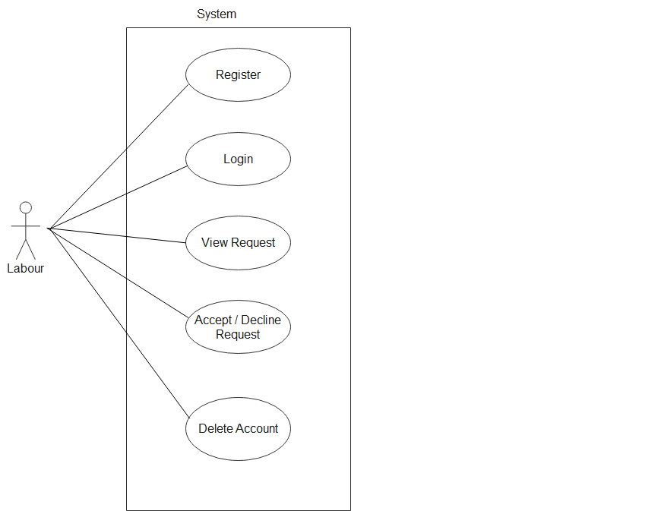

*Fig. Use case diagram for Worker*

1. In Worker use case diagram Farmer is the Actor.
2. Worker can handle following use cases:
3. Register
4. Login
5. Accept Request
6. Decline Request
7. Delete Account

* **Client:**

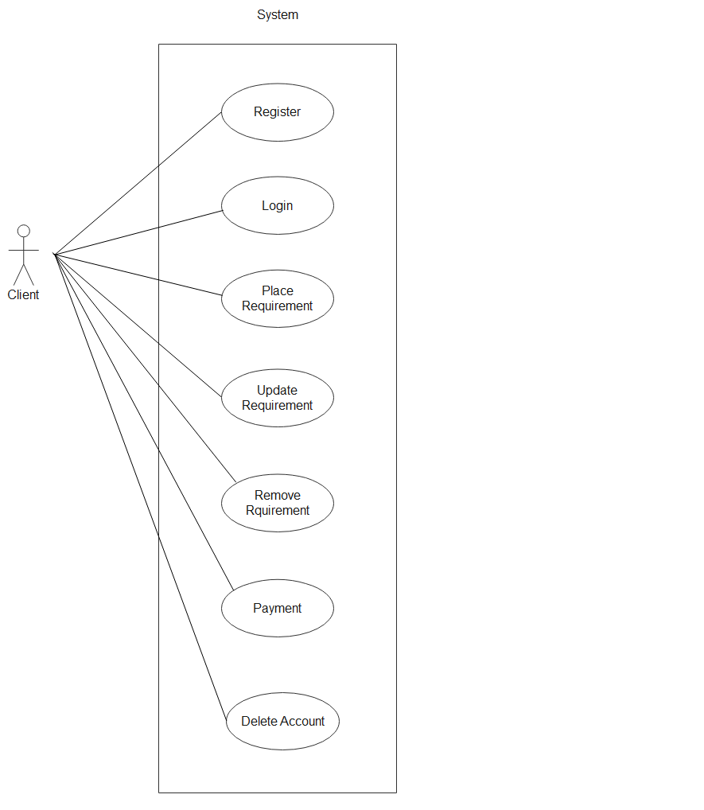

*Fig. Use case diagram for Client*

1. In Client use case diagram Client is the Actor**.**
2. Client can handle following use cases:
3. Register
4. Login
5. Update Account Process
6. Place Requirement
7. Update Requirement
8. Remove Requirement